**ROUGH DRAFT**

**Title:**

Propensity-weighted prognostic associations of hypercapnia by Arterial and Venous Blood Gas: A retrospective, multicenter health records study

**Introduction:**

Arterial blood gases (ABGs) are considered the gold standard for assessing acid-base balance, oxygenation and ventilation status, and remain essential in the management of hypercapnic respiratory failure. However, obtaining an ABG can be uncomfortable for patients, time-consuming and technically challenging, often requiring multiple attempts. Potential complications from ABGs include arterial injury, thrombosis, air or clotted blood embolism, arterial occlusion, hematoma, and aneurysm formation. 1

Given these challenges with ABGs, clinicians have increasingly looked to venous blood gases (VBGs) as an alternative. Hypercapnia results from lungs’ inability to adequately remove carbon dioxide from the bloodstream, leading to its accumulation. On ABG, hypercapnia is defined as greater than 45 mmHg while on VBG, hypercapnia is usually defined as greater than 50 mmHg. VBGs are increasingly being used as a screening tool for hypercapnia due to ease of collection and reduced risk, though they are less precise in measuring arterial pCO₂ compared with ABGs.

Despite their growing use, there has been limited studies comparing VBG versus ABG in diagnosis of hypercapnic respiratory failure, and billing and device qualification guidance does not admit venous blood gas as sufficient evidence of hypercapnic respiratory failure. In a study by Davies et. al, hospitalized patients with known or suspected hypercapnic respiratory failure underwent near-simultaneous ABG and VBG testing. Results demonstrated close agreement in PaCO2 values between ABG and calculated values derived from VBGs, supporting the use of VBGs in monitoring hypercapnic patients.2 Similarly, a review by Lacy et. al analyzed a prospective study which found VBG to have 100% sensitivity in identifying hypercapnia in those with respiratory failure due to COPD exacerbation, pneumonia, heart failure and asthma using PvCO2 greater than 45 mmHg.1 Ak et. al published an additional prospective study in COPD patients in acute exacerbation that found VBG to identify hypercapnia in 100%. 3 In contrast, McKeever found wide variability between arterial and venous CO₂ levels in COPD patients with acute exacerbations, underscoring the limitations of VBG precision.4 Most prior studies have emphasized the analytical agreement between venous and arterial blood gases. Few have examined whether hypercapnia identified by each method carries similar prognostic weight, or whether observed differences reflect patient selection rather than biology. If venous hypercapnia predicts outcomes adverse outcomes such as the need for ventilatory support, this would support using VBGs as diagnostic evidence of hypercapnic respiratory failure.

The objective of this study was to determine the associations of hypercapnia by ABG and VBG with hypercapnia-related outcomes, such as receipt of a diagnosis code for hypercapnic respiratory failure, receipt of invasive mechanical ventilation, receipt of non-invasive ventilation (NIV), and 60-day any-cause mortality, after adjusting for propensity to receive each type of blood gas sampling.

**Methods:**

<https://www.equator-network.org/reporting-guidelines/record/>

1. *How did we get the dataset:  Requested all data from 2022 from TriNetX research network that had at least 1 criteria that would indicate hypercapnia may be present*
2. *What data cleaning did we do: ensured institution was submitting all data.*
3. *A “Table 1” to describe the variables in the dataset*

<https://theeffectbook.net/ch-DescribingVariables.html>

*Guide to help make figures of Table 1 (to show distribution)*

<https://jthomasmock.github.io/gtExtras/articles/plotting-with-gtExtras.html>

1. *Description of correlations with the outcomes of interest*

<https://theeffectbook.net/ch-DescribingRelationships.html>*(the rest of the book looks pretty good, too)*

This multicenter retrospective cohort study using de-identified patent data from the 2022 TriNetX research network (TriNetX, LLC. Cambridge, MA), which aggregates electronic health record data from participating health systems. which provides deidentified individual-level patient data from 76 medical centers across the US serving roughly 115 million patients at the time of data requisition. The University of Utah Institutional Review Board reviewed the study protocol and determined the project met criteria for exemption (IRB #00184622).

**Study Population**

Patients were eligible for inclusion if they had at least one reason indicating a reasonable suspicion might suspect hypercapnia (see e-appendix 4 figure) during Emergency or Inpatient encounter from Jan 1 to Dec 31 2022.

***ambulatory encounters were excluded

Patients with missing key demographic or outcome data were excluded.

**Exposure**

Arterial and Venous blood gas samples from the calendar day of the encounter start were included.

The following LOINC codes were used to identify arterial (LOINC: 2019-8, LOINC: 2026-3, LOINC: 32771-8 ) and venous (LOINC: 115577-6, LOINC: 2021-4) blood gasses.

For patients with VBGs, a “calculated ABG” partial pressure of carbon dioxide (pCO₂) was also estimated using the Farkas equation: Estimated arterial pCO₂=VBG pCO₂−0.22×(93%−VBG O₂ saturation). 5

CO₂ was represented in two ways. First, as a categorical variable: low (PaCO₂ < *, PvCO₂ < ), normal (–* mmHg), and high (PaCO₂ ≥ 45 mmHg, PvCO₂ ≥ 50 mmHg). Second, as a continuous variable using a restricted cubic spline with *** knots, allowing flexible non-linear shapes such as bends or curves.

**Outcomes**

* Hypercapnic respiratory failure diagnosis code: ICD-10-CM codes E66.2, J96.02, J96.12, J96.22, and J96.92
* Receipt of non-invasive ventilation procedure code at any time during the hospitalization
* Receipt of an invasive mechanical ventilation procedure code at any time during the hospitalization
* All-cause mortality within 60 days of encounter start. The 60-day window was selected based on ARDS literature, where this time point captures the greatest intervention-related mortality differences, reflecting the period when deaths attributable to respiratory failure and its management are most apparent.”

**Statistical Modeling**

Separate simple logistic regression models were fit to evaluate the association between pCO₂ category (below normal, normal, above normal) and each of the four outcomes listed above and no adjustment for additional variables. Odds ratios (ORs) with 95% confidence intervals (CIs) were calculated, using the normal pCO₂ group as the reference. Odds ratios from categorical models were displayed using forest plots on a logarithmic scale, stratified by cohort. An additional set of four simple logistic regression models were fit usingrestricted cubic splines. Conditional predicted probabilities of each outcome were estimated across the full observed range of pCO₂ values, with 95% confidence intervals.

To address differences in the types of patients who receive arterial versus venous blood gas sampling, we applied inverse probability of selection weights (IPSWs). This approach estimates each patient’s likelihood of receiving a blood gas based on observed covariates. Patients who were unlikely to be tested but nonetheless had a blood gas drawn are up-weighted, representing similar patients in the population who were not sampled. Separate models were created to model propensity to receive ABG testing and propensity to receive VBG testing. Patients who received ABG testing were then re-weighted by the ABG propensity to approximate the target population of patients with any reason to suspect hypercapnia. Patients who underwent VBG testing were then reweighted to the same population. The resulting reweighted samples to the same target populations allows for comparisons of prognostic significance while adjusting for differences in the types of patients sampled.

Propensity scores were estimated by modeling the likelihood of obtaining an arterial or venous blood gas, belonging to each cohort based on demographic variables (age, sex, race, ethnicity, BMI, location), comorbid conditions diagnosed on or before the index encounter (COPD, asthma, OSA, CHF, neuromuscular disorders, pulmonary hypertension, CKD, diabetes) and other objective data including triage vital signs and basic initial labs. Propensities were estimated using extreme gradient boosting machines (XGBoost; *** parameter settings), a machine learning algorithm that natively handles non-linearities and missing data. Weights were windsorized (truncated) at the 1st percentiles to avoid unstable weights and patients who may have had no realistic chance of receiving blood gas sampling. Covariate balance was evaluated using standardized mean differences, with <0.1 indicating acceptable balance. Additionally, propensity score distributions were compared graphically to assess overlap between groups before and after weighting.

Software: R version ***, using packages rms, weightit ***

Code is available at ***

**Results:**

A total of 833,476 patients met inclusion criteria for the study, see figure CONSORT. Patients were categorized according to blood gas type and the presence or absence of hypercapnia, resulting in six analytic groups. Baseline demographic and clinical characteristics for these groups are summarized in Table 1A and 1B.

Baseline characteristics of patients stratified by ABG results are presented in Table 1A, and those stratified by VBG results are shown in Table 1B. Across the six groups, age and BMI were not significantly different, and sex distribution was approximately equal. The majority of patients were Caucasian and from the Southern region. Patients in the ABG with hypercapnia and VBG with hypercapnia groups had a higher prevalence of COPD, CHF, and pulmonary hypertension compared with the other groups. The mean arterial pCO₂ in the ABG hypercapnia group was 58.2 mmHg, while the mean venous pCO₂ in the VBG hypercapnia group was 60.0 mmHg.

**Table 1A: Baseline Characteristics including demographics, comorbidities and arterial pCO₂** **grouped by no ABG, ABG without hypercapnia and ABG with hypercapnia.**

**Table 1B: Baseline Characteristics including demographics, comorbidities and venous pCO₂** **grouped by no VBG, VBG without hypercapnia and VBG with hypercapnia.**

Figure 1 displays the adjusted odds ratios with 95% confidence intervals, comparing below-normal and above-normal pCO₂ groups to the normal reference group for invasive mechanical ventilation, noninvasive ventilation, 60-day mortality, and diagnosis of hypercapnic respiratory failure. The below-normal pCO₂ groups demonstrated odds ratio close to 1.0 for non-invasive ventilation and hypercapnic respiratory failure, suggesting little difference compared with the normal pCO₂ group. In contrast, patients in the above-normal pCO₂ groups had substantially higher odds of receiving non-invasive ventilation and being diagnosed with hypercapnic respiratory failure. Across the four outcomes, the above-normal pCO₂ for ABG and VBG were consistent and not statistically significant.

**Figure 1: Inverse Propensity Weighted Odds Ratio of Outcomes by pCO₂ Category (below normal pCO₂ and above normal pCO₂. The above normal pCO₂ groups have much higher likelihood of receiving noninvasive ventilation and diagnosis of hypercapnic respiratory failure compared to the below normal pCO₂ group.**

To further examine the continuous relationship between pCO₂ and clinical outcomes, restricted cubic spline models were constructed. Figure 2A, 2B and 2C present the predicted probabilities for each outcome across pCO₂ values, stratified by ABG, VBG and calculated ABG groups.

In Figure 2A, there is a notable increase in the likelihood of receiving invasive ventilation among patients with hypercapnia (arterial pCO₂ > 45 mmHg). There is also a slight increase in the likelihood of being diagnosed with hypercapnic respiratory failure when hypercapnia is present on ABG. In contrast, the likelihood of receiving non-invasive ventilation showed minimal change among hypercapnic patients. Finally, mortality appeared unrelated to CO₂ status, suggesting that death in this cohort is more reflective of overall illness severity rather than hypercapnia itself.

**Figure 2A: Inverse Propensity Weighted Predicted Probability by ABG for the four outcomes. There is significant higher likelihood of patients with hypercapnia on ABG receiving invasive mechanical ventilation as opposed to non-invasive ventilation or diagnosis of hypercapnic respiratory failure. Lastly, mortality appears unrelated to pCO₂ status.**

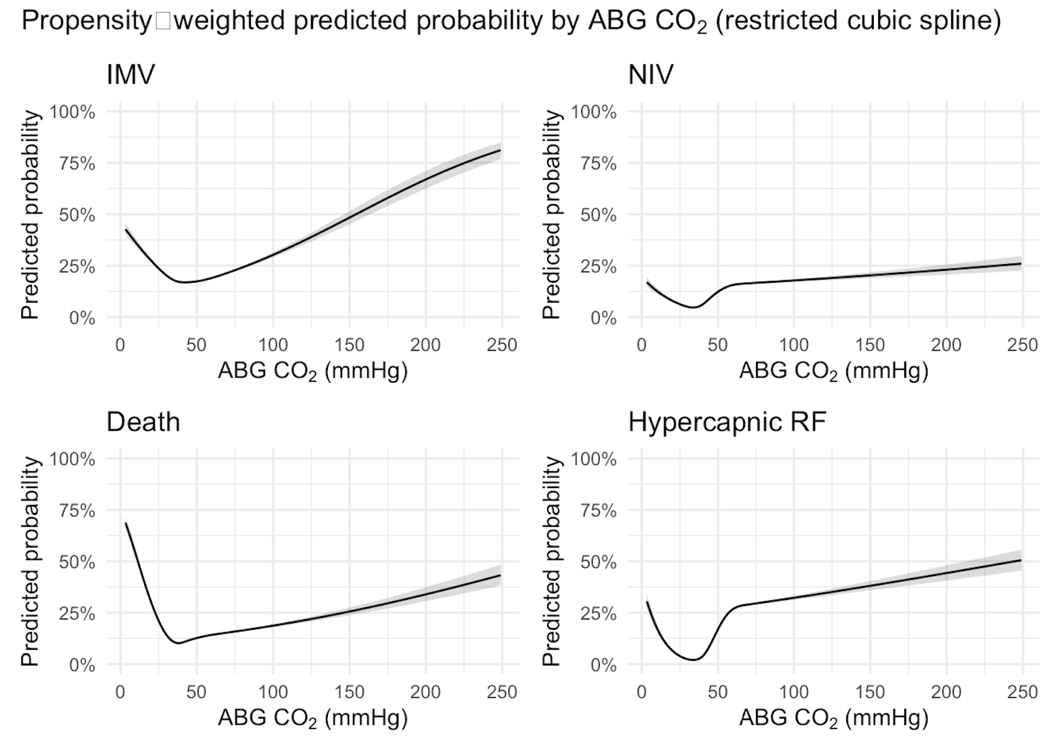

In Figure 2B, there is also a notable increase in the likelihood in receiving the four outcomes in patients with hypercapnia on VBG (greater than 50 mmHg). As venous pCO₂ rises, the predicted probability of each outcome increases and approaches nearly 100% across all four outcomes.

**Figure 2B: Inverse Propensity Weighted Predicted Probability by VBG across four outcomes. The four outcomes across VBG groups are more similar to each other and there is a notable increase in predicted probability of receiving the four outcomes for hypercapnic patients on VBG.**

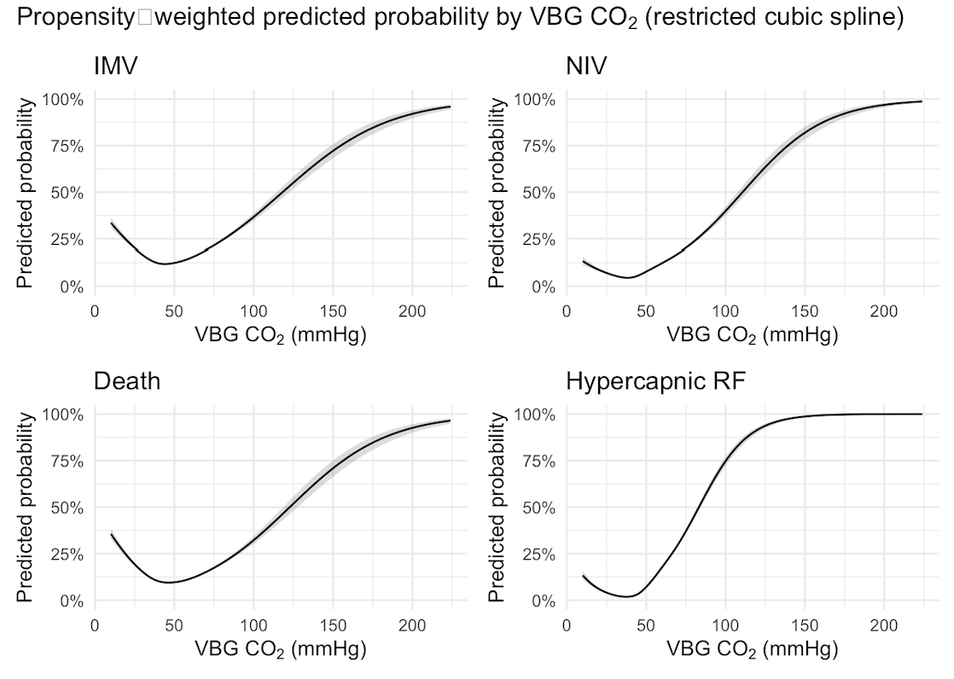

In Figure 2C, VBG values were converted to estimated ABG values using the Farkas equation, and the probabilities of the four outcomes were depicted. In this group, non-invasive ventilation, and the diagnosis of hypercapnic respiratory failure showed higher predicted probabilities among hypercapnic patients. In contrast, invasive ventilation and mortality demonstrated weaker associations with hypercapnia, suggesting that mortality in this cohort may be more reflective of overall illness severity rather than pCO₂ levels alone.

**Figure 2C: Inverse Propensity Weighted Predicted Probability of outcomes using calculated ABG pCO₂ (Farkas equation). Hypercapnia was associated with higher predicted probability of noninvasive ventilation and diagnosis of hypercapnia respiratory failure, but weaker associations with invasive ventilation and mortality.**

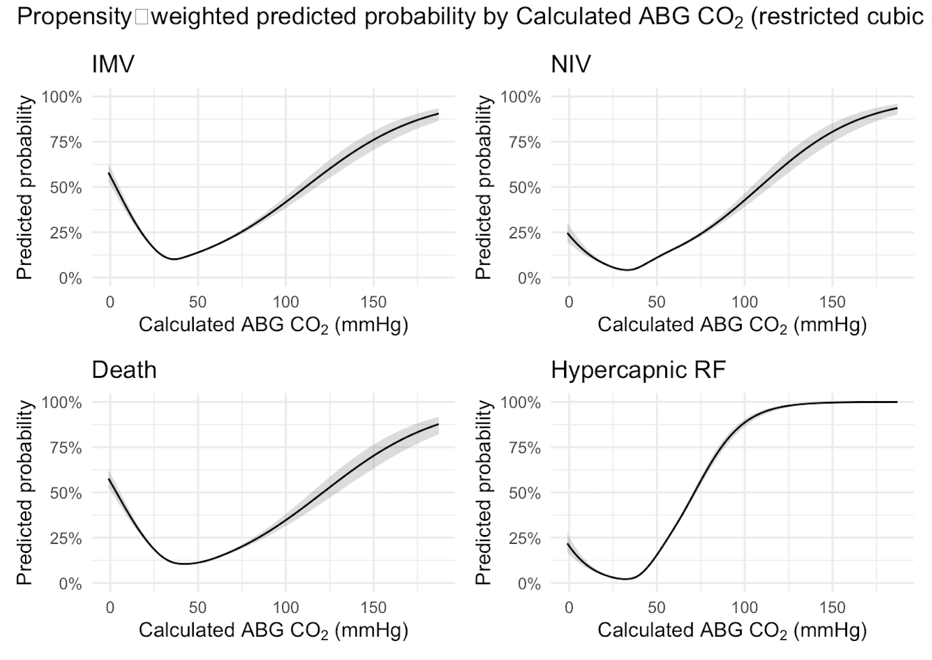

Figure 3 below shows the distribution of the inverse propensity weighted scores across ABG, VBG and Calculated ABG groups. Patients who did not receive an ABG or VBG are concentrated near 0, indicating that most patients who were not tested had a very low estimated probability of undergoing testing. There is some overlap between the patients who received a blood gas and those who did not, which is essential for the validity of weighting, as it ensures that each tested patient can be compared to similar untested patients. Additionally, the distribution of patients who underwent blood gas testing is skewed toward higher weights, as expected, since sicker patients are more likely to receive blood gas testing.

**Figure 3: Distribution of Inverse Propensity-Weighted Scores for ABG, VBG and Calculated ABG groups. Untested patients clustered near zero, while tested patients were skewed toward higher probabilities of being tested.**

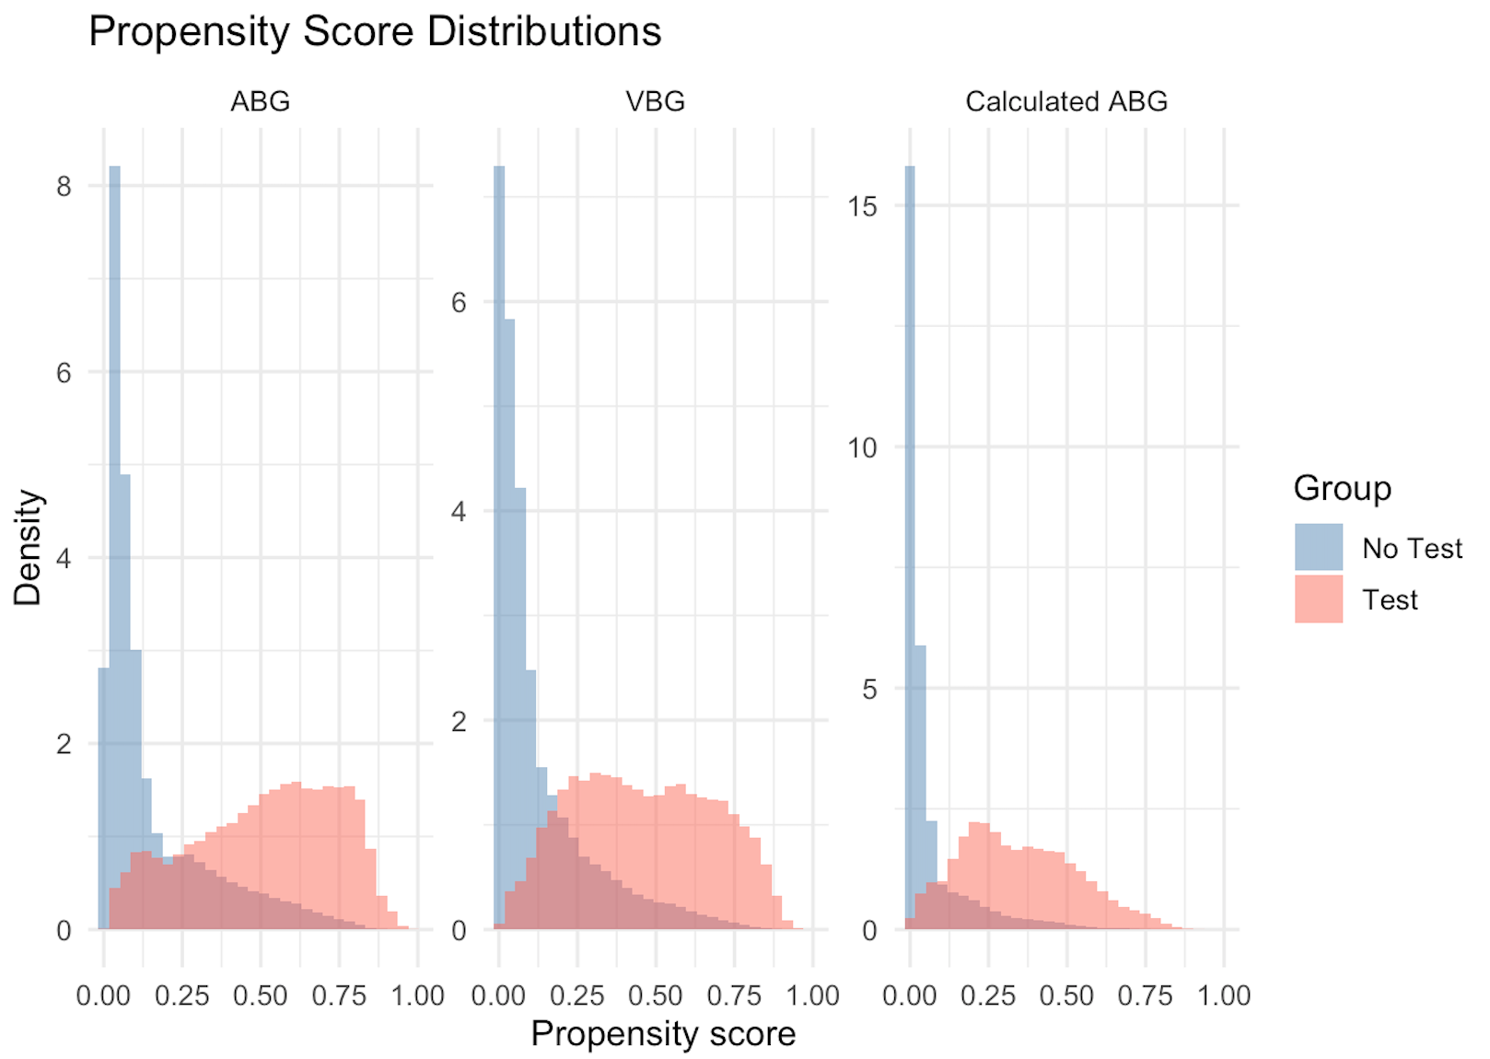

**Discussion:**

Overall, these findings suggest that venous and arterial blood gas measurements provide comparable clinical information in predicting key outcomes, including non-invasive ventilation, invasive mechanical ventilation, diagnosis of hypercapnic respiratory failure and 60-day mortality. The absence of significant differences between VBG and ABG groups indicate that VBG testing may be sufficient for guiding management decisions in many patients, potentially reducing the need for more invasive arterial sampling.

Previous studies have shown that venous and arterial pCO₂ values are strongly correlated. The prior work has focused on diagnostic accuracy or correlation coefficients rather than clinical outcomes. Our study expands upon this literature by linking arterial and venous blood gas measurements to meaningful clinical outcomes such as mechanical ventilation and mortality. Our study findings are

**Strength and Limitations**

This study has several strengths. It leverages a relatively large cohort of patients across multiple institutions which enhances the generalizability and external validity of the findings. The study design reflects real-world clinical practice by stratifying patients who underwent either ABG or VBG testing, providing insight into how hypercapnia is assessed and managed across different clinical contexts. The use of multivariable logistic regressions and inverse propensity weighting allowed for the adjustment of measured cofounders and provided a robust assessment of associations between hypercapnia and important clinical outcomes such as mechanical ventilation, non-invasive ventilation and 60-day mortality. Propensity scores were estimated using a machine learning method that accommodates non-linear relationships and missing data.

However, this study does have certain limitations. The retrospective design of this study eliminates casual inference and is at risk for confounders that bias results. Unmeasured variables such as provider practice style or illness severity may have influenced both the likelihood of testing and clinical outcomes. Since data was extracted from the electronic health record, misclassification or missing data in comorbidities, test results or outcomes is possible. This study relied on single blood gas measurements obtained on any day throughout the counter, which limits the ability of assess temporal changes in pCO₂ or the effect of repeated sampling over time.

Further work is needed to confirm these findings in prospective studies. Randomized clinical trials comparing ABG versus VBG management could more directly establish causality and inform guidelines. Repeated measurements throughout a patient encounter as well would also better capture the relationship between changing pCO₂ values and outcomes. Additionally, subgroup analyses focusing on specific patient populations with certain comorbidities will further clarify whether VBGs are equally reliable as ABGs.

**Conclusion:**

**References:**

1. Lacy ME, Saa L, Bruss Z, Noronha L. Things We Do for No ReasonTM: Arterial blood gas testing to screen for hypercarbic respiratory failure. *J Hosp Med*. 2025;20(9):1002-1004. doi:10.1002/jhm.70039

2. Davies MG, Wozniak DR, Quinnell TG, et al. Comparison of mathematically arterialised venous blood gas sampling with arterial, capillary, and venous sampling in adult patients with hypercapnic respiratory failure: a single-centre longitudinal cohort study. *BMJ Open Respir Res*. 2023;10(1):e001537. doi:10.1136/bmjresp-2022-001537

3. Ak A, Ogun CO, Bayir A, Kayis SA, Koylu R. Prediction of Arterial Blood Gas Values from Venous Blood Gas Values in Patients with Acute Exacerbation of Chronic Obstructive Pulmonary Disease. *Tohoku J Exp Med*. 2006;210(4):285-290. doi:10.1620/tjem.210.285

4. McKeever TM, Hearson G, Housley G, et al. Using venous blood gas analysis in the assessment of COPD exacerbations: a prospective cohort study. *Thorax*. 2016;71(3):210. doi:10.1136/thoraxjnl-2015-207573

5. Farkas J. PulmCrit. How to convert a VBG into an ABG. January 16, 2017. https://emcrit.org/pulmcrit/vbg-abg/

**Supplement:**

Things like the propensity diagnostics could be included in the supplement.